Business analysis: Citizen Science verge inventory and management in urbanized Flanders

V. Strosse
Researcher, Department of the Environment, Flanders, Belgium

Corresponding author: E-mail: Veerle.strosse@vlaanderen.be, Tel +32 474 59 11 27

Abstract
Verges form an important part of the green-blue veins of urbanized Flanders, which can be considered as one large city. They play an important role in relation to climate change, numerous ecosystem services, and genetic diversity to combat pests. Green-blue permeation, including road verges, forms the foundation of resilient cities.
There is a need for a uniform inventory of Flemish verges and their quality for all of Flanders. Through this overview, we know which verge location needs to be actively addressed, for example through adapted verge management. Currently, there are numerous verge inventories, which however all are conducted in very different methods. This research builds on a previous study on Flemish verges that developed a scoring system for the verges and carried out an initial integration of existing verge inventories. With this current research, carried out on behalf of the Flemish Department of Environment, we want to get a more detailed view of the quality of the Flemish verges using a scoring system. We want to do this through Citizen Science and at the same time raise awareness about the importance of biodiverse verges. In this study, we carried out a business analysis, in preparation for an app that will be developed in the context of the Citizen Science project. All stakeholders were surveyed using different research techniques, and a communication strategy for the end users was defined. To confirm the viability of this approach, we developed a proof of concept in the validation phase, containing a solution for technical issues. The analysis found that the app ideally targets two audiences: nature lovers without and with species knowledge. The proof of concept showed that essential functionalities include location determination, registration of flora and fauna, photographic documentation, date and time registration, and space for user notes. For the communication strategy, we recommend a broad approach, aimed at nature lovers and various groups who often seek out nature. The communication should share facts about biodiversity in Flemish verges and the launch of the app is best supported by both traditional media and digital marketing.
The results and recommendations of this research allow us to continue with the development of the app for the Citizen Science project for verge inventory. This will ultimately not only lead to a uniform verge inventory, where data exchange is possible, but also to more support in relation to the importance of verges, as part of the green-blue veins in urbanized Flanders. And in this way, this research contributes to a more resilient Flanders.

Keywords: verges, business analysis, Citizen Science, green-blue veins of Flanders

1. INTRODUCTION

Verges collectively constitute a fundamental component of the ecological structure and the green-blue network within the landscape. Beyond their importance for biodiversity, these verges - as an essential part of the green-blue veining - play a crucial role in mitigating climate change, delivering ecosystem services, and preserving genetic diversity. In urbanized Flanders, they serve as essential buffers against the urban heat island effect, providing necessary cooling. However, biodiversity in Flanders faces significant challenges due to various factors, including environmental pollution, land use expansion, spatial fragmentation, barriers, monocultures, and pesticide usage. Addressing these issues is critical for maintaining ecological balance. There is a need for a uniform inventory of Flemish verges and their quality for all of Flanders. Through this overview, we know which verge location needs to be actively addressed, for example through adapted verge management. We achieve this by deriving a comprehensive scoring system and visualizing this information on maps in the study of 2022, namely ‘Onderzoek Vlaamse bermen en onmiddellijke omgeving in het kader van groenblauwe netwerken en de afname van biodiversiteit’ [Investigation of Flemish Roadside Verges and Immediate Surroundings in the Context of Green-Blue Networks and Biodiversity Decline] [1].

Understanding the biodiversity status of the verges informs optimal verge management strategies based on their respective scores. Currently, there are numerous verge inventories, but they were all conducted in very different methods. There is a need for a standardized verge inventory to enable data exchange and comparison across different verges. Building upon the above-mentioned first verge study [1], we propose data collection through a Citizen Science project. An accompanying mobile application will facilitate data gathering. Additionally, the Citizen Science initiative will raise awareness about the importance of roadside verges.

This article also discusses the business analysis carried out in the context of the preparation of the app development and outlines the communication strategy associated with the proposed app, as described in the report of 2024, ‘Business analyse: Citizen Science Berminventarisatie en -beheer’ [Business analysis: Citizen Science Roadside Inventory and Management] [2].

2. FIRST STEPS TO INTEGRATION OF ROADSIDE INVENTORY

Two studies have already been conducted on this topic. In the first study [1], the need for a comprehensive overview of Flemish road verges was highlighted. However, to gain insight into the quality of these verges, a robust inventory methodology (via Citizen Science) with data collection in a reliable database and an ecological score are essential requirements.
This first study on verges [1] consists of three parts: integrating existing roadside inventories, setting up a scoring system and initiating a Citizen Science study.
Firstly, data from existing inventories provided by the Flemish Waterway Authority (Vlaamse Waterweg nv) and the Agency for Roads and Traffic (Agentschap voor Wegen en Verkeer) were analysed. A high-performance relational (geo) data model was developed to seamlessly integrate existing databases containing information about these verges without any data loss.
Second, to assess the quality of the verges, a dual scoring system was devised based on landscape-ecological and biotic values. The landscape-ecological value, with a score from 1 till 10, considers the verge’s proximity to legally protected natural areas (such as nature reserves) and watercourses. In the figure below (Figure 1), this scoring system with landscape-ecological value has been applied to the verges in Flanders.
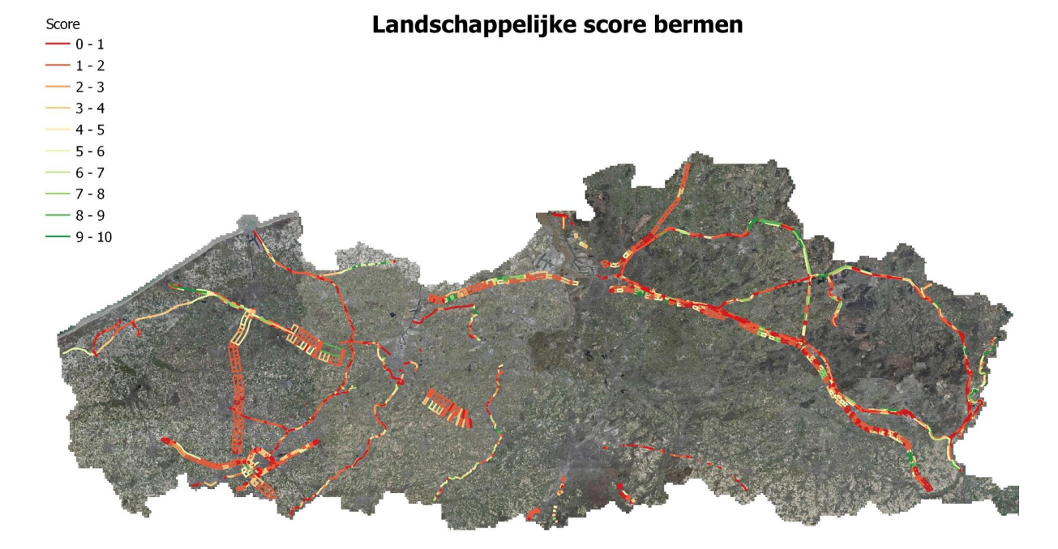
Landscape-ecological score
Figure 1. Landscape-ecological score of the roadsides (Anteagroup & Natuurpunt, 2022)
Additionally, the score considers adjacent land use, exposure, and slope (Figure 2). The biotic score relies on verge characterization and the presence of red-listed species (both fauna and flora) and has a score from 1 till 20.
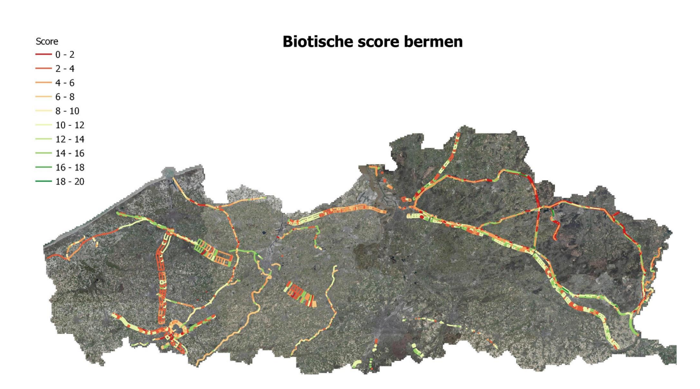
Biotic score
Figure 2. Biotic score of the roadsides (Anteagroup & Natuurpunt, 2022)
This first study also serves as a stepping stone toward a Citizen Science project. It identifies success and failure factors based on known Citizen Science projects and outlines an action plan for the Citizen Science initiative, leveraging the established database.
In the policy recommendations emphasis is placed on expanding the database. This expansion would involve local managers in verge maintenance and allow for the derivation of baseline data and trends to inform management tips. Expert assessment remains crucial for establishing effective management practices (e.g., practical considerations)."
Furthermore, it is emphasized that a sufficiently robust communication component (with targeted awareness and motivation) needs to be established to engage administrators, associations, etc. In terms of the follow-up process, it is indicated that it is crucial that the various stakeholders and developers work together to actively utilize the results of this study.
The current research builds on the preliminary investigation and focuses extensively on stakeholder mapping and surveys. In addition, the Citizen Science project was further developed into a proof of concept.

3. NEXT STEPS – RESEARCH QUESTIONS

The second study on verges [2] presents the results of the business analysis for the development of an app for a Citizen Science project on verge management and inventory. The analysis includes a definition of the goals, a thorough investigation, an internal and joint brainstorming, an elaboration of a proof of concept and advice on a matching communication strategy. The main findings indicate that the app would be optimally aimed at both nature lovers with and without knowledge of plant species. Through features such as location tracking, flora and fauna registration, photographic documentation and user notes, the app has the potential to deliver significant added value to existing verge management in Flanders.
Thus, the main objectives of this business analysis are the following: a stakeholder mapping, the realisation of a proof of concept and a communication strategy.
For the business analysis of the application, the following research questions were asked (objectives).
- Who owns the app?
- What functionalities should the app have?
- What data should the app record?
- How is app management organized?
- How is data intered into the app?
- Who processes the data and how is it handled?
- What will be the cost of the app, including app management and processing the data entered in the application?
In line with this, the following questions must be answered when providing advice regarding the communication strategy:
- What is the target audience?
- Which content needs to be communicated?
- How will the app be launched (via which tools, which media)?
- How will further guidance and follow-up occur after the app’s launch?
This part of the paper includes objectives with the research questions. In the following, the methods to answer these questions will be briefly described.

4. NEXT STEPS - METHOD AND RESULTS

Stakeholder consultation
An extensive stakeholder analysis examined and surveyed the key stakeholders for roadside research and roadside management. This ultimately resulted in an overview.
The stakeholder mapping related to roadside inventory and management identifies the various stakeholders, including their shortcomings, obstacles, and gains. It also assesses the available knowledge about these stakeholders and identifies any missing information.
During flow workshops with different stakeholders, the research maps both the current (as-is) and desired (to-be) flow. In this research, we meticulously go through all the steps of the various processes involved in inventorizing (and sometimes managing) roadside areas. The outcome is a business process map that captures the different flows resulting from the research.
Additionally, the research conducts interviews with users (traditional observers, novice volunteers, average citizens, schools, municipalities, etc.) to understand their needs, desires, and current customer journey. The investigation specifically examines their existing interactions with government initiatives and identifies their main motivations and obstacles, aiming to address the latter.
Using all the gathered information, the research creates several personas and customer journey maps. The personas (four types: volunteers with extensive natural knowledge, volunteers with limited natural knowledge, volunteers with no natural knowledge, and biology teachers) focus on the different stakeholders, their needs, desires, and frustrations. The customer journey map highlights the processes and how stakeholders navigate them, including where they seek information, through which channels and which other target groups they interact with. A customer journey reflects the context and behaviour of an individual within a user group, describing both the current state (as-is) and a potential future state (to-be).

In this section, we will briefly describe the main conclusions of this research phase:
- Project Objective Clarity: It is crucial to define the project’s objective precisely. This research identifies issues related to awareness among citizens and challenges in monitoring, knowledge, and communication within institutions and municipalities regarding roadside management. If the goal is to accurately inventorize road verges, multiple parameters must be considered, with a focus on naturalists as primary users. However, if the aim is to raise awareness and sensitize the public, fewer parameters are necessary, allowing for a broader audience reach.
- Tailoring Content for Different Audiences: As mentioned in the previous study (Heylen et al., 2022), content alignment with various target groups is essential. For instance, when communicating information within the tool to (novice) volunteers or young individuals, we need an approach that is easy to understand. Since knowledge is essential for plant recognition and effective inventorizing, the provided information should be clear and visually presented. Additionally, the application may benefit from training sessions or informational meetings. On the other hand, for experts, the application should not be overly simplified. Their expertise warrants efficient execution of tasks and input to optimize roadside management.
- Ensuring Data Quality: To maintain high-quality input data, consideration should be given to methods for error checking and prevention of misuse. Allocating limited additional resources or time to monitor and address erroneous or incomplete inventory data within the Citizen Science project is crucial.

Proof of concept
In this phase, a prototype of the concept was developed to validate the technical feasibility or report any remaining limitations. The focus and content of this prototype are based on the findings from the research phase.
At the start of the proof of concept (POC), two possible tracks were identified based on the research conducted by Heylen et al (2022) [1]. The first track involved creating an entirely new application, while the second track aimed to develop an app connected to waarnemingen.be. Both tracks were carefully analysed, with extensive research to map out the specific advantages and disadvantages of each approach. The findings of this research can be found below.
The first track, focused on developing a completely new app, is characterized by several notable benefits. A crucial advantage is the ability to have full control over both the design and functionalities of the app. This allows the development team to tailor the application precisely to specific needs and objectives. However, these advantages are offset by some drawbacks, including higher development costs and a longer development timeline.

On the other hand, the second track, focused on developing an app connected to waarnemingen.be, also presents an interesting set of advantages and challenges. A significant advantage of this approach is the ability to leverage an existing platform with an established user base. This can result in lower development costs and an accelerated implementation timeline, as building upon an existing infrastructure is feasible. Furthermore, the benefit of having pre-existing data and functionalities provides a solid foundation for further development. However, the reduced level of control over app functionalities, compared to the first track, is considered a drawback. Additionally, there is a need to consider the dependency on the external platform and the inherent limitations it brings. This includes constraints on customization and integration, which are crucial factors in decision-making during the development process.

The research questions from part 2 of this paper and their corresponding answers are concisely presented in Table 1 below.

Table 1. Research questions and answers derived from the research.

Who owns the app? | The entity responsible for the app is the Flemish Environmental Assessment Agency (owner)
What functionalities should the app have? | 1. Location tracking, 2. Registration of flora and fauna, 3. Photographic documentation, 4. Date and time registration, 5. User Notes
What data should the app record? | 1. Location, 2. Type of observation (flora and fauna), 3. Description, 4. Date and time, 5. Additional Notes
How is app management be organized? | The technical party that develops the app is responsible for the management of both the app and the associated data.
How is data intered into the app? | (1) automation through existing systems, (2) user input, (3) validation and quality control.
Who processes the data and how is it processed? | Since the technical party chosen for the development of the app is in charge of the processing of the data, this responsibility includes a thorough series of steps aimed at ensuring the secure, organized, and easily accessible storage of the data received: (1) processing for secure storage, (2) rapid search and geolocation, (3) data analysis and reporting. This comprehensive approach to data processing by the technical party guarantees secure storage of the data lays the foundation for a quick and effective use of this data to identify valuable insights and trends. The stored data is considered a static entity, and a dynamic resource that contributes to the app's success in understanding and conserving biodiversity.
What will be the cost of the app, including app management and processing the data entered in the app? | (1) development costs, (2) management fees

Figure 3 provides a simplified representation of a possible look of the app. However, the app needs further development in a follow-up study.

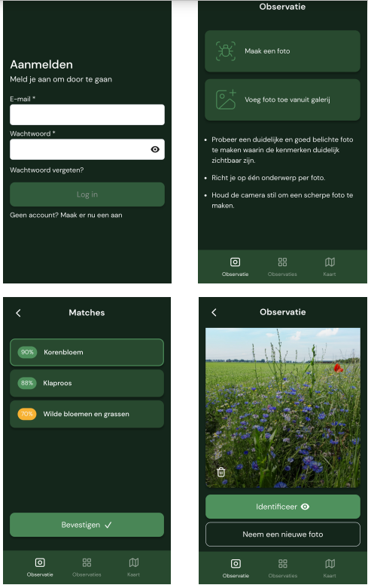
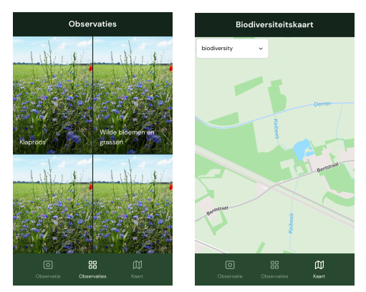
Figure 3. Proof of concept of the application (Wisemen, 2024)

Communication strategy
The research questions in order to communication (cfr. part 2 of this paper) and their corresponding answers are concisely presented in Table 2 below.

Table 2. Research questions and answers in order to communication, derived from the research.

What is the target audience? | Nature lovers, groups that often seek out nature. Reaching individuals with marketing is fine, but also: the wider the participating audience, the better.
Which content needs to be communicated? | (1) Information about the verges, (2) Brand story, which consists of three parts: status quo, conflict, resolution, (3) Creating content categories (e.g. roadside hero), which has the following benefits: targeted communication and recognizability.
How will the appbe launched (via which tools, which media)? | Balance between traditional media and digital marketing (each with advantages and disadvantages), launch event, PR as a cost-efficient tool, App Store Optimization (ASO) and Search Engine Optimization (SEO), Email marketing, Influencer marketing, Boost your app with reviews, measure and adjust goals.
How will further guidance and follow-up occur after the app’s launch? | App Store Optimization (ASO) and Search Engine Optimization (SEO) is important to increase the app's visibility on different platforms. Email marketing is recommended for activating existing users and using the network of stakeholders. Influencer marketing with influencers in environmental and nature-related domains can increase brand awareness. The importance of positive reviews and effectively measuring and adjusting goals using collected data is emphasized for long-term success.

5. CONCLUSION
Preparatory steps were taken in the previous studies [1] and [2] to develop an app for the Citizen Science Project. In the business analysis, all kinds of questions are answered about the app and a proof of concept is made that can be tested by the partners of this research. A communication strategy has been developed in parallel. The answers to all these questions form a preparation for the next phase, so that we can immediately proceed to the development of the app needed for the Citizen Science project. Undoubtedly, additional questions will arise and will have to be investigated during the development of the app. Based on the proposed communication strategy, the next step is to proceed with a broad communication of the project.
The Citizen Science project for verge inventory will ultimately not only lead to a uniform verge inventory, but also to more support in relation to the importance of verges, as part of the green-blue veins in urbanized Flanders. In this way, this research contributes to a more resilient Flanders with more resilient cities. The results can also form an important approach for environmental urban planning, which will become increasingly important, given the impending climate effects.

References

- Heylen, O., Engelen, B., Debbaut, R., Impens, W., Lambrechts, J., Steeman, R. (2022), Onderzoek Vlaamse bermen en onmiddellijke omgeving in het kader van groenblauwe netwerken en de afname van biodiversiteit (Depotnummer D/2021/3241/318). Departement Omgeving
- Bijnens, P., Vandewalle, O. (2024), Business analyse: Citizen Science Berminventarisatie en -beheer. Business analyse en ontwikkelen proof of concept ter voorbereiding van app voor vervolgonderzoek Vlaamse Bermen (Citizen Science) en uitwerken bijhorende communicatiestrategie (Depotnummer D/2023/3241/280). Departement Omgeving

